W18Ev1.0-How to Change the Connection Type?

Note: This guidance will guide you how to change the connection type if the router is not in Factory settings or the current connection type is wrong. The detail steps as below:

Step 1: Connect your computer to a LAN port of the router.

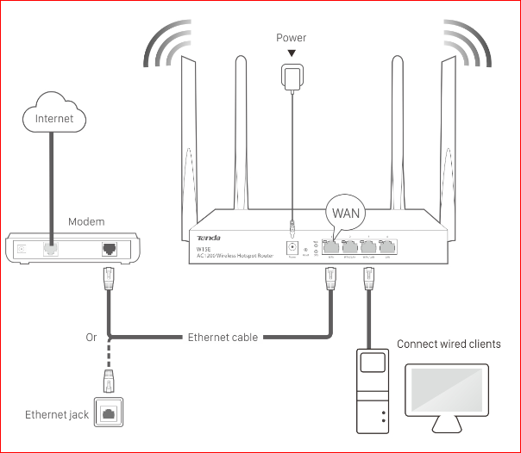

Step 2: Open a Web Browser -> Input tendawifi.com or 192.168.0.1 in the address bar -> Press Enter.

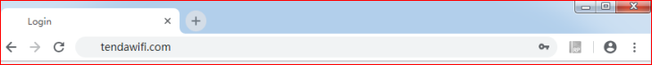

Step 3: Enter the login password and click Login.



Step 4: Select Internet Settings -> Connection Type

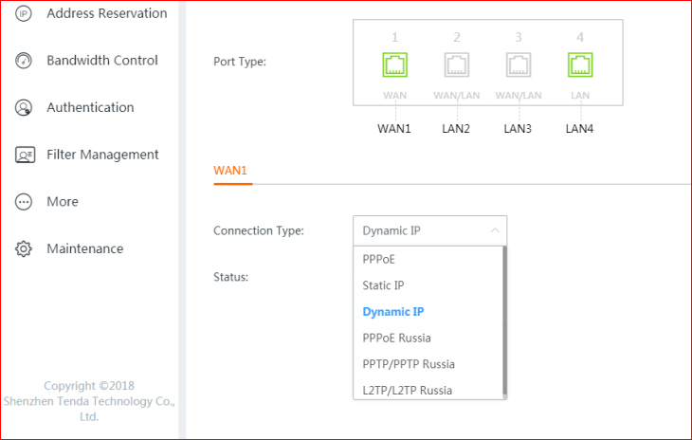

Step 5: Select the correct Connection Type and enter the correct parameters which provided by ISP.
Note: If you forget the connection type or do not know the correct connection type, please contact your ISP.

Step 6: Check the System Status and it can access Internet.

